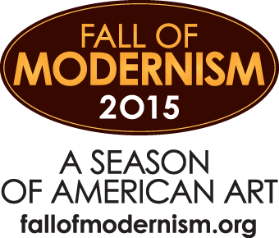

FALL OF MODERNISM BOILERPLATE
TO INCLUDE AT THE BOTTOM OF ALL GALLERY PRESS RELEASES
ABOUT THE FALL OF MODERNISM:
The Fall of Modernism is a citywide collaboration that celebrates the Modernist art movement in America and runs from September of 2015 through January of 2016 anchored by the New Mexico Museum of Art and the Georgia O’Keeffe Museum. The New Mexico Museum of Art will present two exhibitions, Georgia O’Keeffe in Process and An American Modernism: Painting and Photography. It is complemented by the Georgia O’Keeffe Museum’s exhibition, From New York to New Mexico: Masterworks of American Modernism from the Vilcek Foundation Collection. Numerous art galleries in Santa Fe will showcase Modernist art with exhibitions, programming, and events. For information about the exhibitions, related public events, and a joint museum- ticketing program, the public is invited to check the web site fallofmodernism.org.

